Ex. No. : 01D Date: 02-02-2026
Register No.: 231701023 Name: S.V.Jashwanth

Temperature Convertor
Aim
Create an app that converts temperatures between Celsius and Fahrenheit. Users can enter a temperature in an EditText, press a Button to perform the conversion, and see the result in a TextView.

Procedure:
- Open Android Studio and create a new project using Empty Activity.

- Select Kotlin as the programming language.

- Design the layout with an EditText to enter the temperature, Buttons for conversion, and a TextView to display the result.

- Open the MainActivity.kt file and connect the EditText, Buttons, and TextView using findViewById.

- Write the conversion logic for Celsius to Fahrenheit and Fahrenheit to Celsius.

- When the user presses a button, the entered temperature is converted.

- Display the converted value in the TextView.

- Run the app and verify the conversion output.

AndroidManifest.xml

<?xml version="1.0" encoding="utf-8"?>
<manifest xmlns:android="http://schemas.android.com/apk/res/android"
xmlns:tools="http://schemas.android.com/tools">
<application
android:allowBackup="true"
android:dataExtractionRules="@xml/data_extraction_rules"
android:fullBackupContent="@xml/backup_rules"
android:icon="@mipmap/ic_launcher"
android:label="@string/app_name"
android:roundIcon="@mipmap/ic_launcher_round"
android:supportsRtl="true"
android:theme="@style/Theme.TemperatureConvertor">
<activity
android:name=".MainActivity"
android:exported="true">
<intent-filter>
<action android:name="android.intent.action.MAIN" />
<category android:name="android.intent.category.LAUNCHER" />
</intent-filter>
</activity>
<meta-data
android:name="preloaded_fonts"
android:resource="@array/preloaded_fonts" />
</application>
</manifest>

Activity_main.xml

<?xml version="1.0" encoding="utf-8"?>
<LinearLayout xmlns:android="http://schemas.android.com/apk/res/android"
xmlns:app="http://schemas.android.com/apk/res-auto"
xmlns:tools="http://schemas.android.com/tools"
android:id="@+id/main"
android:layout_width="match_parent"
android:layout_height="match_parent"
android:orientation="vertical"
tools:context=".MainActivity" >
<TextView
android:id="@+id/textView"
android:layout_width="match_parent"
android:layout_height="wrap_content"
android:fontFamily="@font/alegreya_semibold"
android:gravity="center"
android:text="Temperature Convertor"
android:textSize="34sp" />
<EditText
android:id="@+id/txtTemp"
android:layout_width="match_parent"
android:layout_height="wrap_content"
android:layout_marginLeft="20dp"
android:layout_marginTop="20dp"
android:layout_marginRight="20dp"
android:ems="10"
android:hint="Enter Temperature"
android:inputType="number|numberDecimal" />
<Button
android:id="@+id/btnCtoF"
android:layout_width="match_parent"
android:layout_height="wrap_content"
android:layout_marginLeft="20dp"
android:layout_marginTop="40dp"
android:layout_marginRight="20dp"
android:text="Celsius to Fahrenheit" />
<Button
android:id="@+id/btnFtoC"
android:layout_width="match_parent"
android:layout_height="wrap_content"
android:layout_marginLeft="20dp"
android:layout_marginTop="40dp"
android:layout_marginRight="20dp"
android:text="Fahrenheit to Celsius" />
<TextView
android:id="@+id/txtResult"
android:layout_width="match_parent"
android:layout_height="58dp"
android:layout_marginLeft="20dp"
android:layout_marginTop="40dp"
android:layout_marginRight="20dp"
android:fontFamily="sans-serif"
android:gravity="center"
android:text="0"
android:textSize="34sp" />
</LinearLayout>

MainActivity.kt

package com.example.temperatureconvertor
import android.os.Bundle
import android.widget.Button
import android.widget.EditText
import android.widget.TextView
import androidx.activity.enableEdgeToEdge
import androidx.appcompat.app.AppCompatActivity
import androidx.core.view.ViewCompat
import androidx.core.view.WindowInsetsCompat
class MainActivity : AppCompatActivity() {
override fun onCreate(savedInstanceState: Bundle?) {
super.onCreate(savedInstanceState)
enableEdgeToEdge()
setContentView(R.layout.activity_main)
val txtTemp=findViewById<EditText>(R.id.txtTemp)
val txtResult=findViewById<TextView>(R.id.txtResult)
val btnCtoF=findViewById<Button>(R.id.btnCtoF)
val btnFtoC=findViewById<Button>(R.id.btnFtoC)
btnCtoF.setOnClickListener {
if (txtTemp.text.isNotEmpty()) {
val c = txtTemp.text.toString().toDouble()
val f = (c * 9 / 5) + 32
txtResult.text = "Celsius: %.2f --> Fahrenheit: %.2f".format(c, f)
} else {
txtResult.text = "Enter a value"
}
}
btnFtoC.setOnClickListener {
if (txtTemp.text.isNotEmpty()) {
val f = txtTemp.text.toString().toDouble()
val c = (f - 32) * 5 / 9
txtResult.text = "Fahrenheit: %.2f --> Celsius: %.2f".format(f, c)
} else {
txtResult.text = "Enter a value"
}
}
ViewCompat.setOnApplyWindowInsetsListener(findViewById(R.id.main)) { v, insets ->
val systemBars = insets.getInsets(WindowInsetsCompat.Type.systemBars())
v.setPadding(systemBars.left, systemBars.top, systemBars.right, systemBars.bottom)
insets
}
}
}

Output
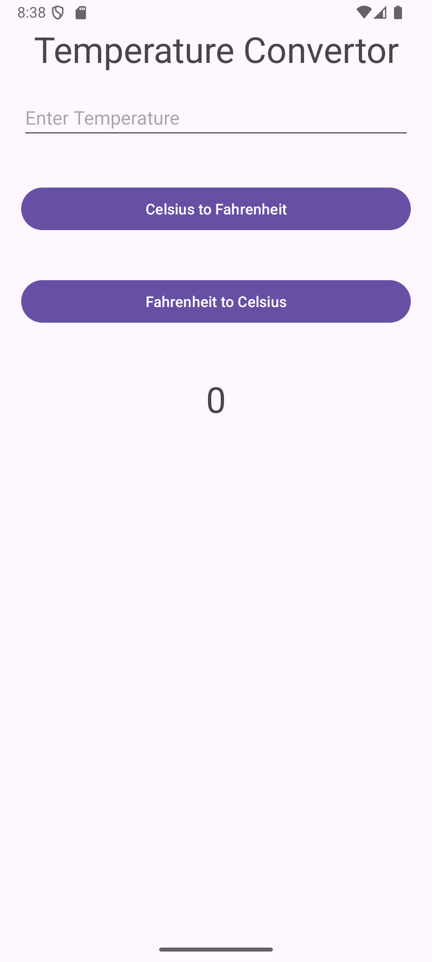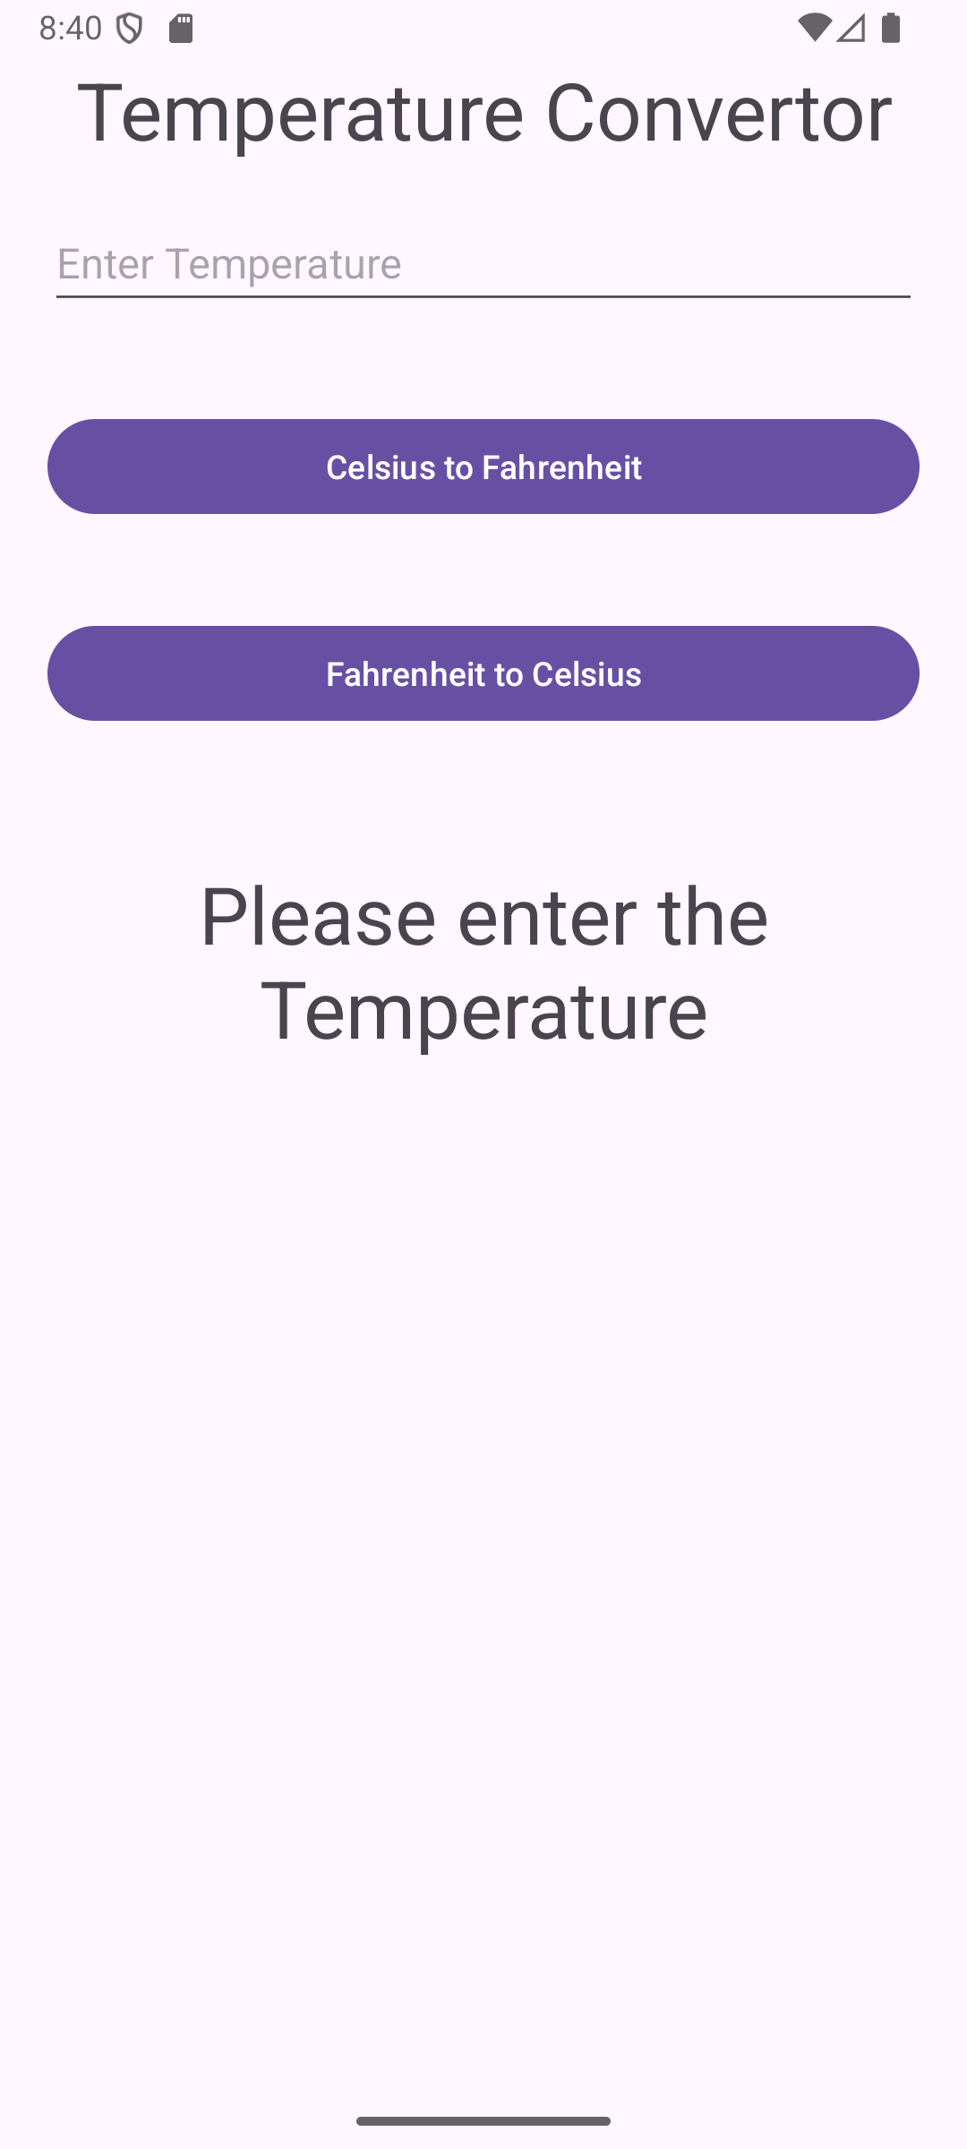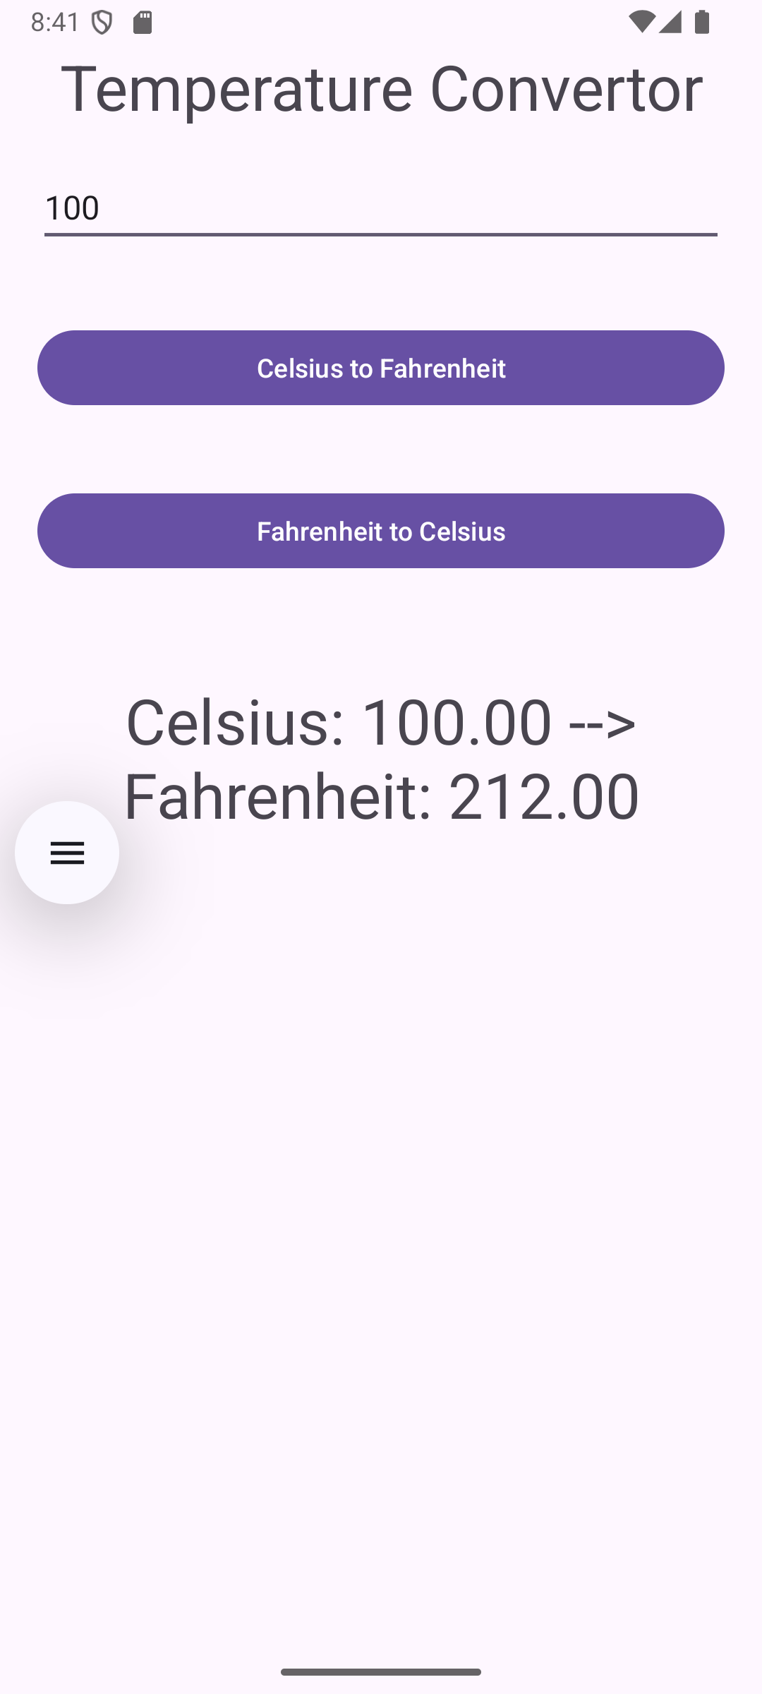

Result:
The application was successfully developed.
It converts temperature values between Celsius and Fahrenheit and displays the result when the user presses the conversion button.

